Lab 1

# Lab Status – Working

# Three Things I’ve Learned

1. How to create a REST API with Visual Studios
2. How to use GET and POST functions with Controllers
3. How to create a unit tests with Visual Studios

# Three Things I Need to Work On

1. Lambda expressions
2. Better unit testing
3. Rely less on others when looking for help

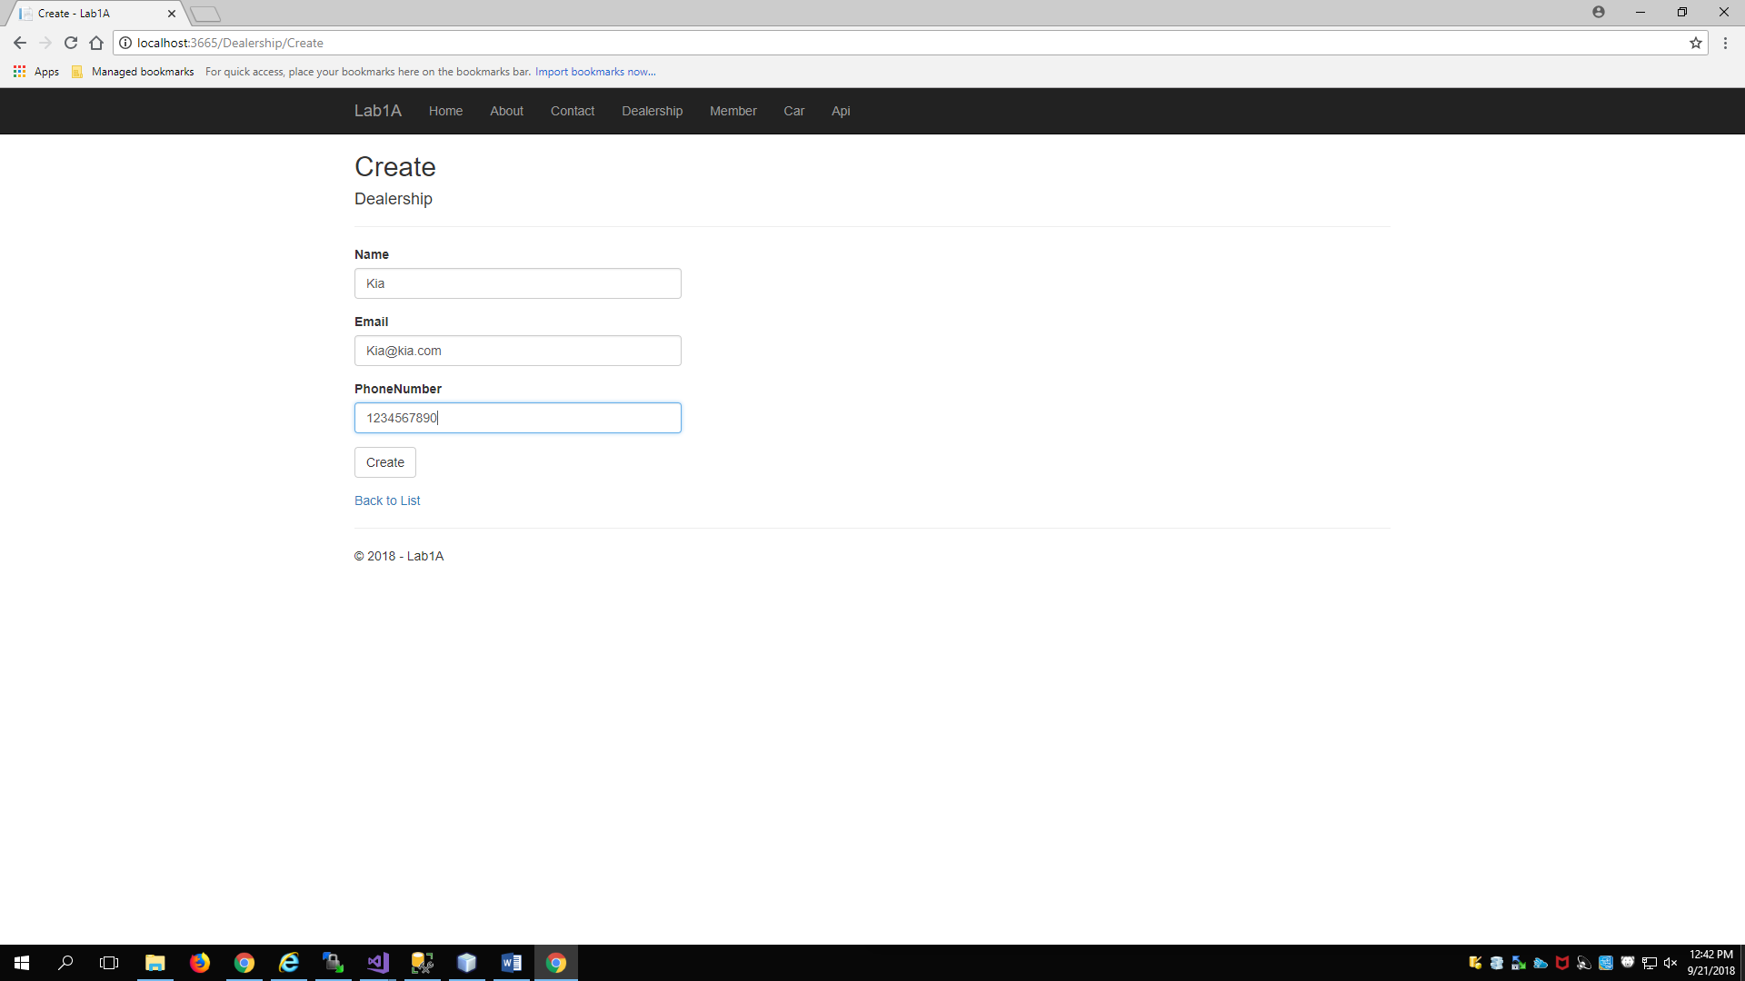

User enters data in the Create Dealership Page^

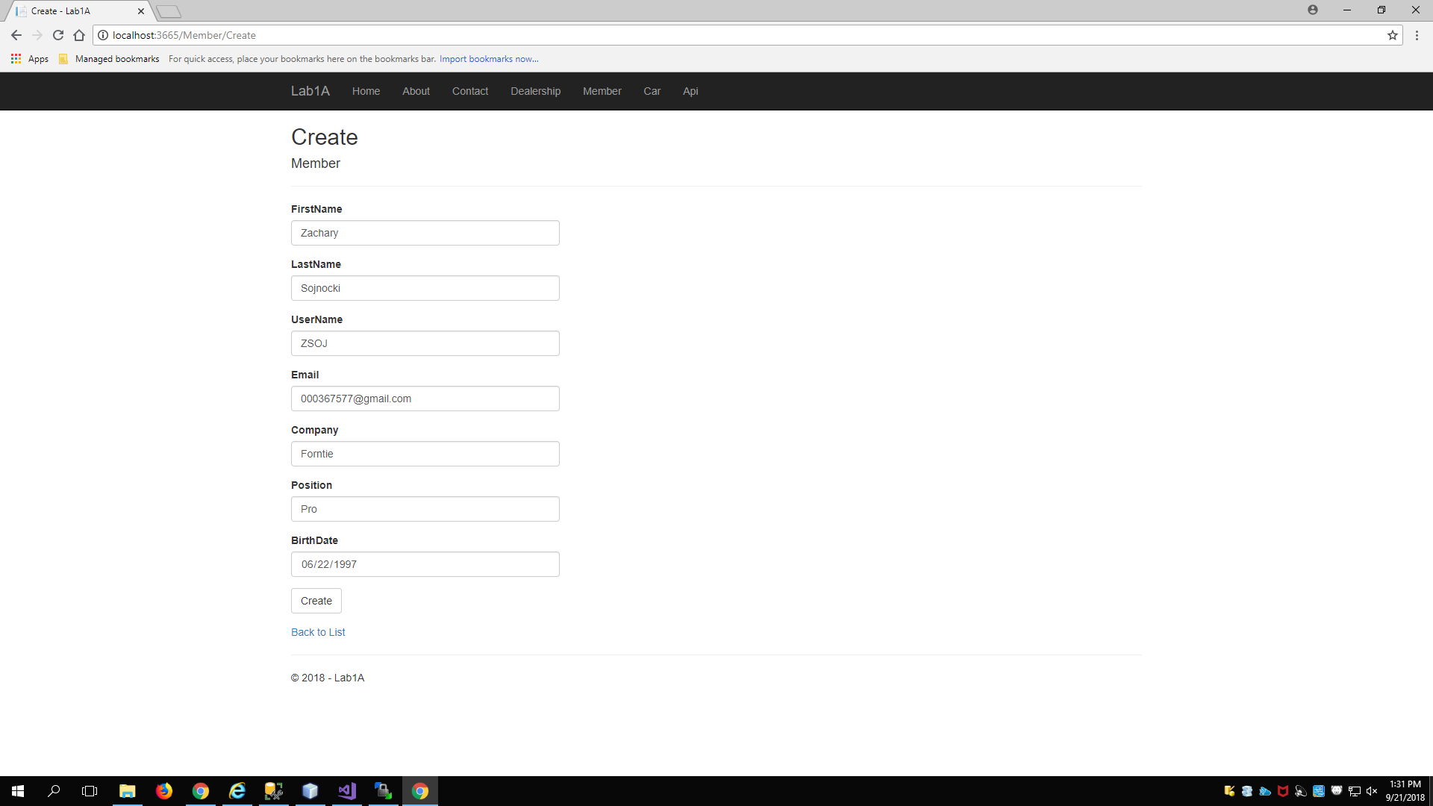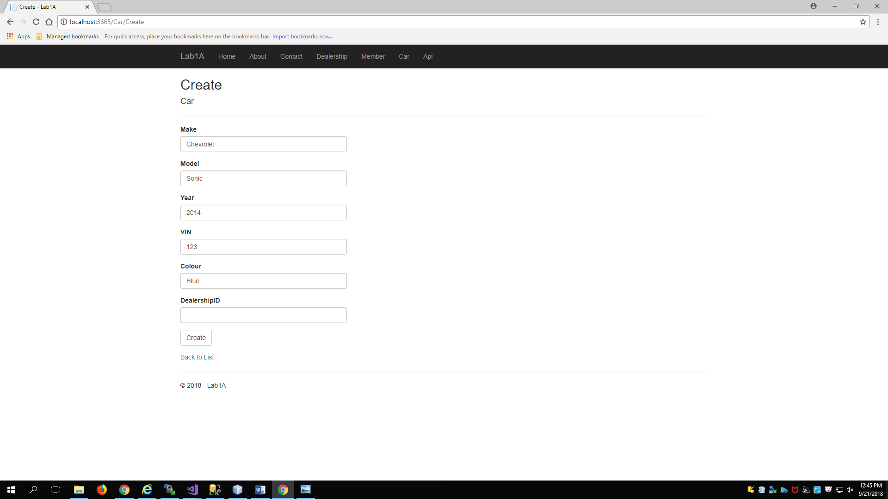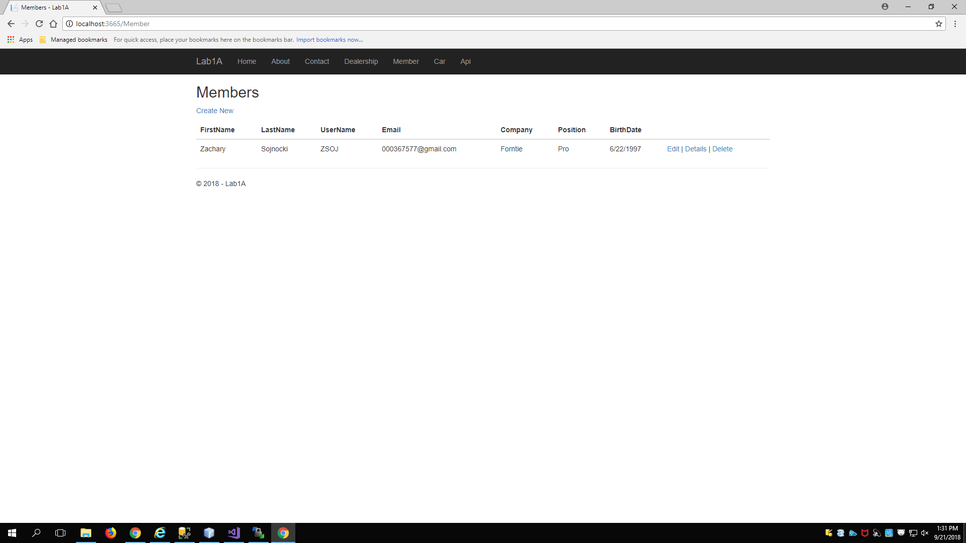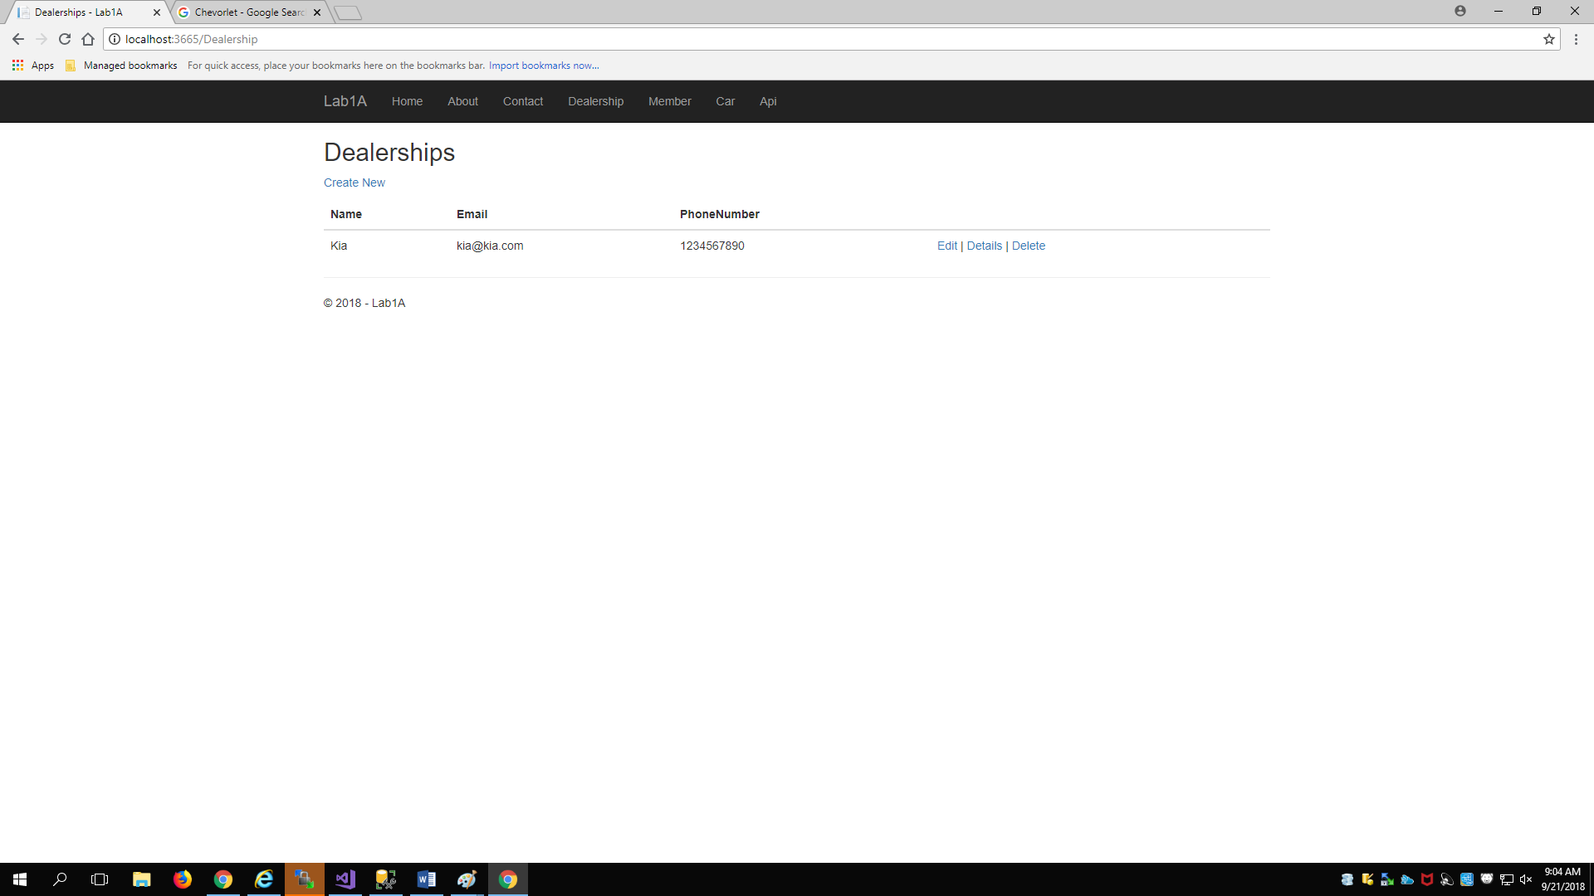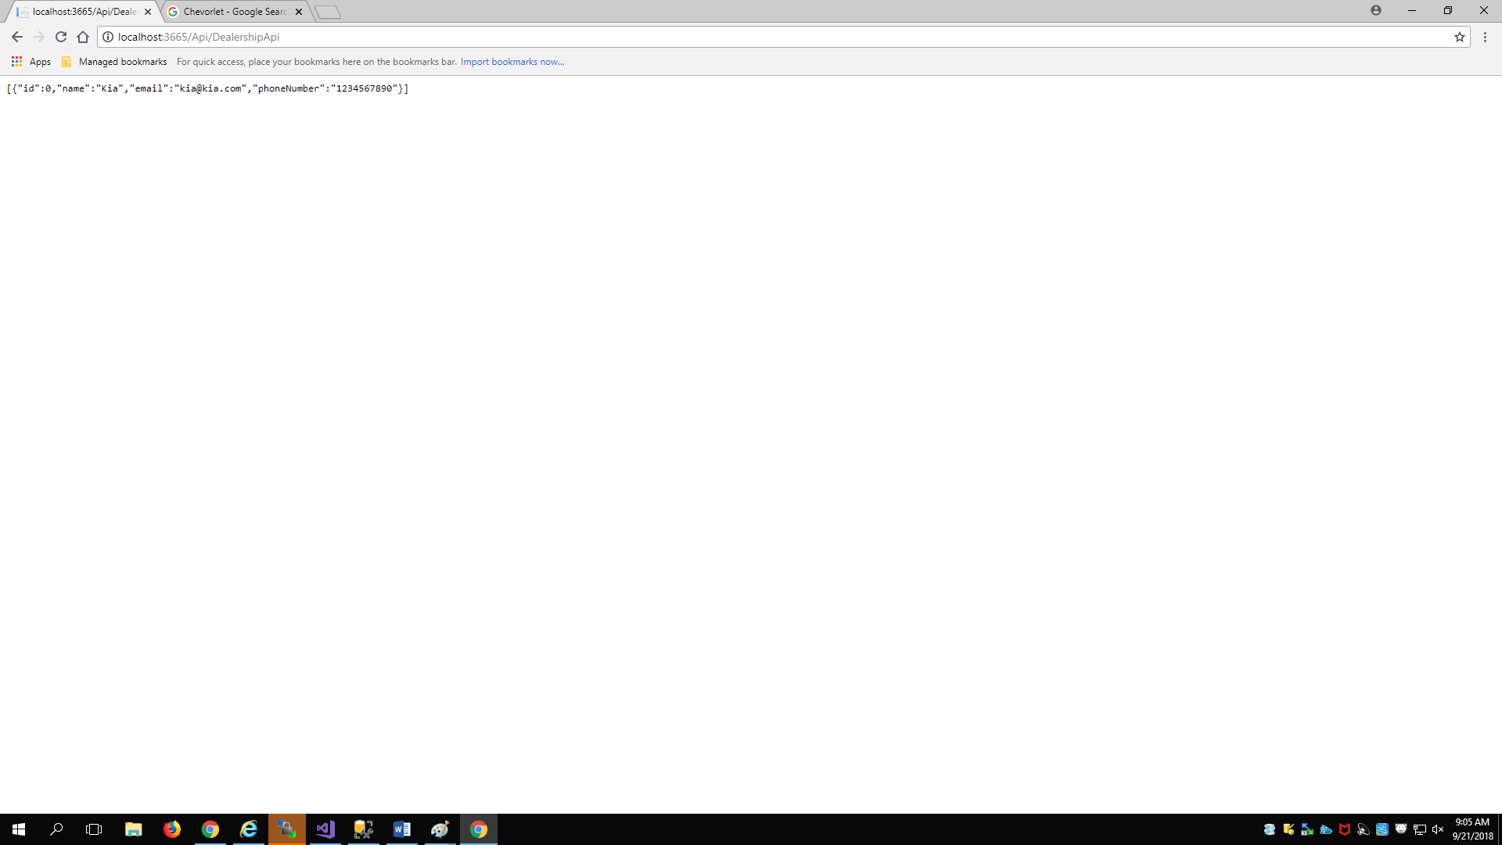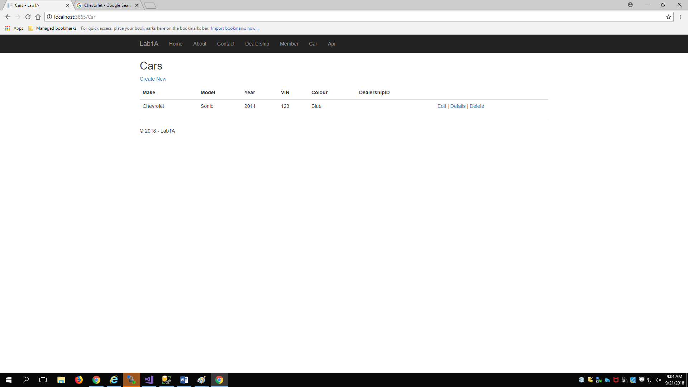

User enters data in the Create Member Page^

User enters data in the Create Car Page^

User clicks ‘Create’ from the Create Member page

User clicks ‘Create’ from the Create Dealership page

User clicks ‘Api’

User clicks ‘Create’ from the Create Car page^

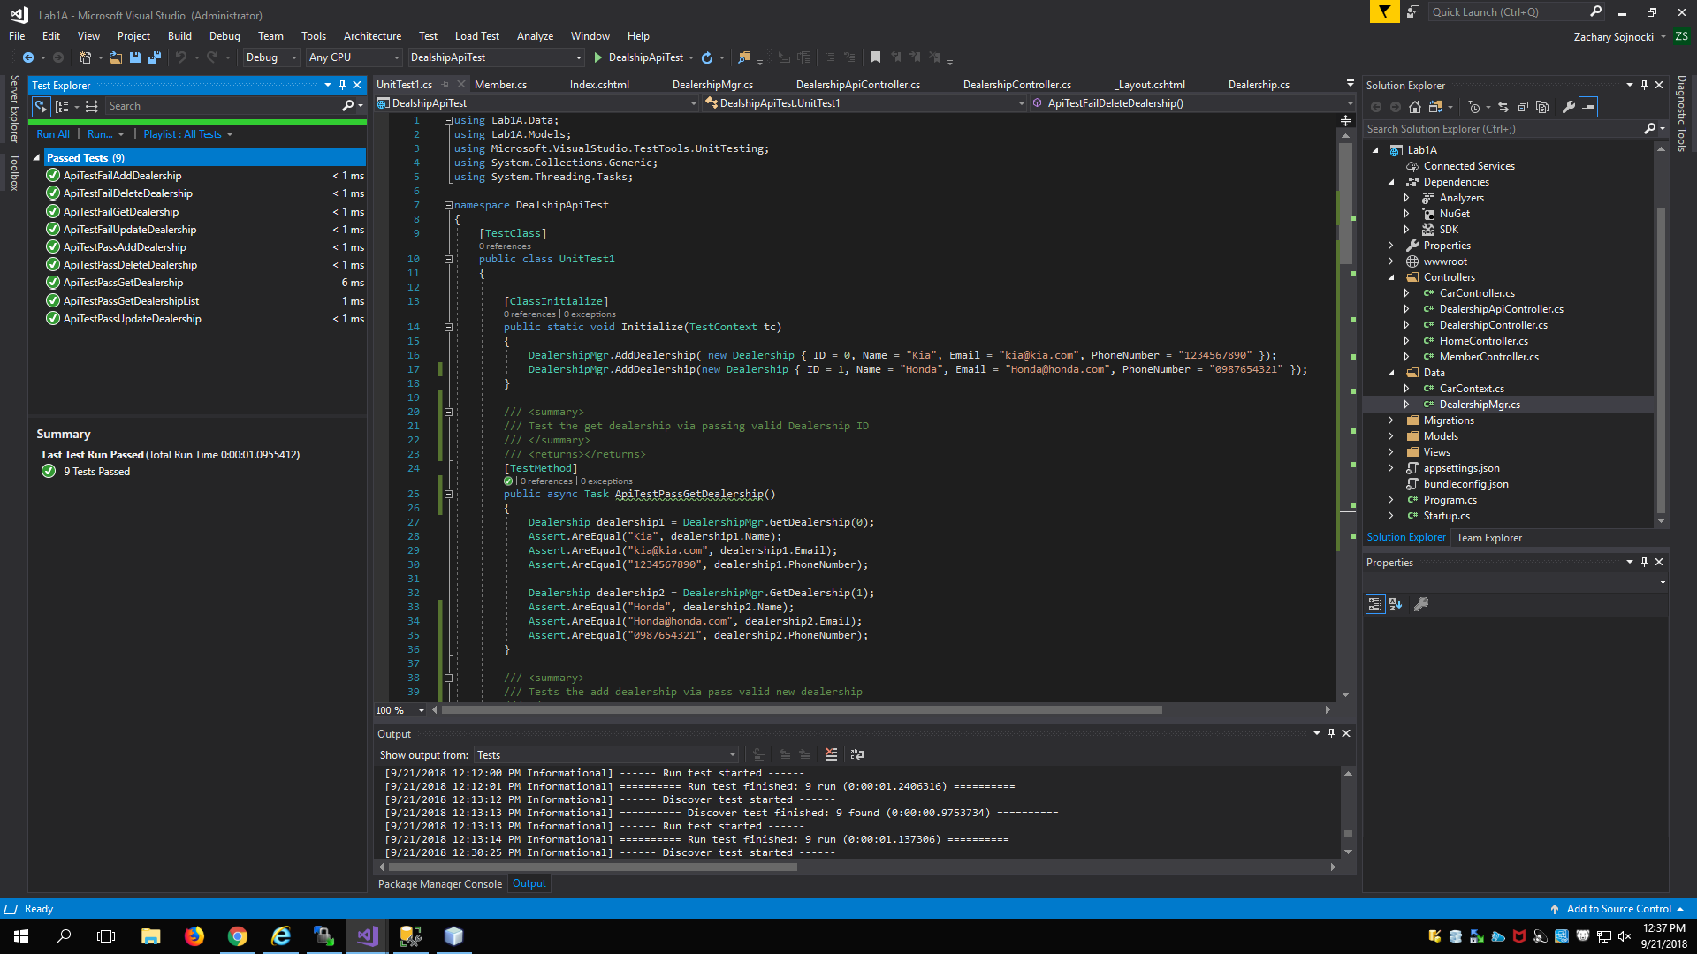

Unit Test results

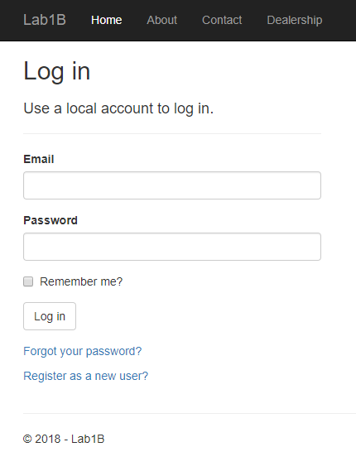

Non-user trying to use the dealership controller

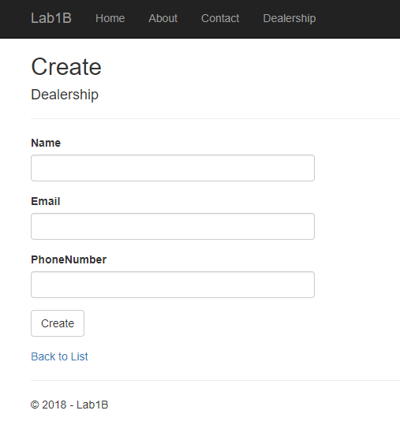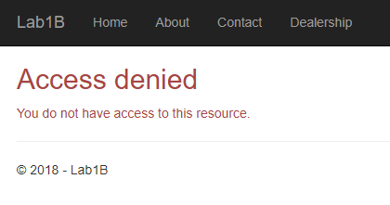

Manager creating a new dealership

Employee trying to create a dealership